**The State Of The Industry: A Deep Dive Into Video Game Sales Trends**

Team member : RACHAMALLA MOHAN SUJITH

**Introduction:**

Video games since its inception has touched many souls by their augmented reality and graphics apart from being a good to boredom it is also show us the way technology has been developed from single Ninendo to PS5, from road rash to God of war.

This project is a complete analysis of video games sold since 1980.It consist of video games with their publisher and platform with the genre of games on which year they were published with the sales they made in North America, Japan, Europe and other regions.

**Problem Statement:**

Analysing sales data from more than 16,500 games. This dataset contains a list of video games with sales greater than 100,000 copies.It was generated by a scrape of vgchartz.com.

**Technical Architecture:**

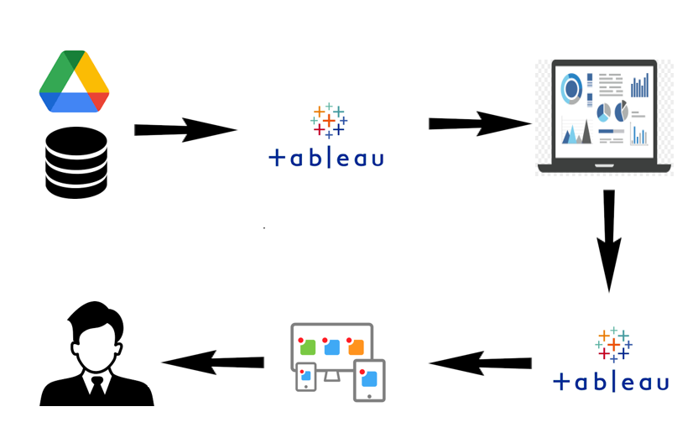

### Prerequisites

* MySQL

Create a Tableau Desktop Account with a student’s ID

Create a Tableau Public account with a personal ID

### Project Flow

1. Users create multiple analysis graphs/charts.
2. Using the analysed chart creation of Dashboard is done.
3. Saving and visualizing the final dashboard in the Tableau Desktop.

To accomplish this, we must complete all the activities and tasks listed below

* MySQL workbench Account
* Login to Tableau
* Working with the Dataset
  + Understand the Dataset
  + Database connection
* Data visualization charts
  + Problem Statement 1: Sales in different region Analysis
  + Problem Statement 2: Genre with rank Analysis
  + Problem Statement 3: Total Sales Analysis
  + Problem Statement 4: Top 5 publishers Analysis
  + Problem Statement 5: Best 10 selling genres on platform Analysis
  + Problem Statement 6: Top 10 EU selling video games Analysis
  + Problem Statement 7: Top 10 Japan selling video games
  + Problem Statement 8: Top 10 NA selling video games
* Dashboard Creation
* Story Creation
* Conclusion

**Install MySQL Workbench**

Use the below link to download and install mysql workbench

* https://dev.mysql.com/downloads/workbench/

### Install Tableau Desktop

* <https://www.tableau.com/products/desktop/download>

### Working With Dataset

### Understand The Data

The data source of this project contains a list of video games with sales greater than 100,000 copies. It was generated by a scrape of [vgchartz.com](http://www.vgchartz.com/).

Fields include

* Rank - Ranking of overall sales
* Name - The games name
* Platform - Platform of the games release (i.e. PC, PS4, etc.)
* Year - Year of the game's release
* Genre - Genre of the game
* Publisher - Publisher of the game
* NA_Sales - Sales in North America (in millions)
* EU_Sales - Sales in Europe (in millions)
* JP_Sales - Sales in Japan (in millions)
* Other_Sales - Sales in the rest of the world (in millions)
* Global_Sales - Total worldwide sales.

Dataset can be accessed using the below link

### Data Visualization Charts

Sales In Different Region Analysis

Genre With Rank Analysis

Total Sales Analysis

Top 5 Publishers Analysis

Best 10 Selling Genres On Platform Analysis

Top 10 EU Selling Video Games Analysis

Top 10 Japan Selling Video Games Analysis

Top 10 NA Selling Video Games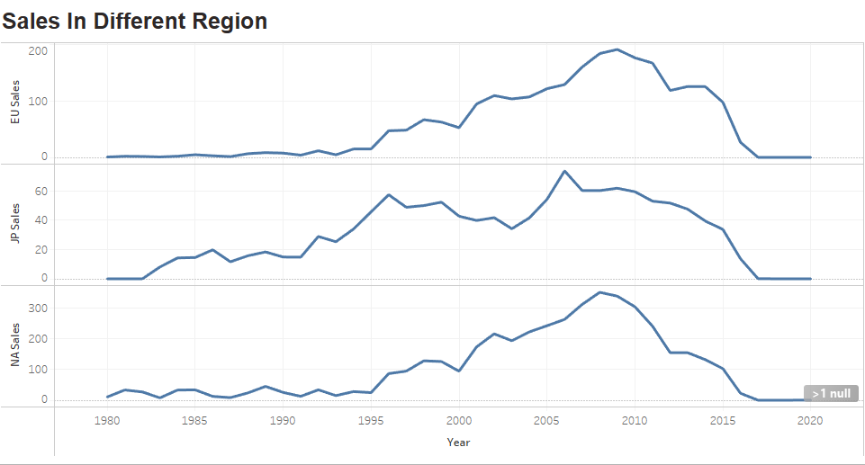

## DASHBOARD FOR DATA VISUALIZATION CHARTS IN THIS DASHBORD WE CAN ANALYSISE THE DATA ON THE BASIS ON SALES IN DIFFERENT REGION

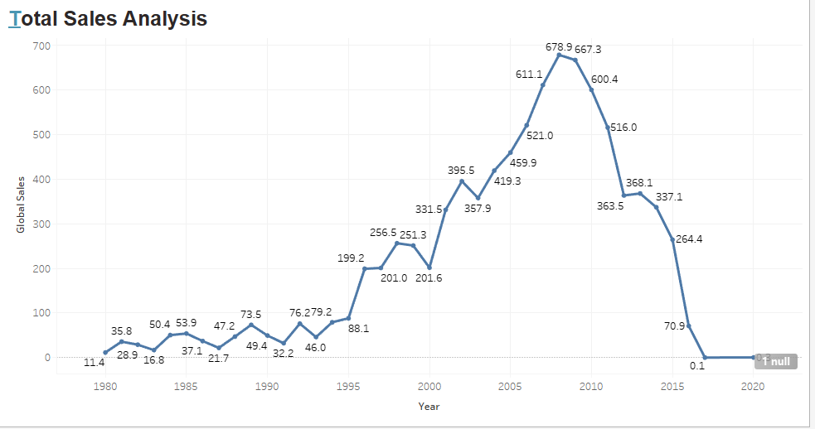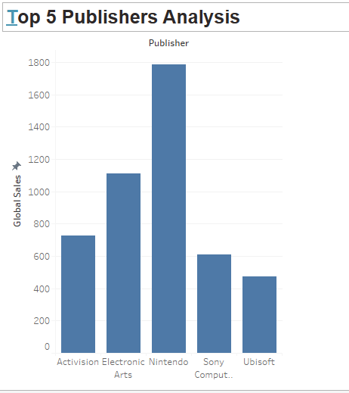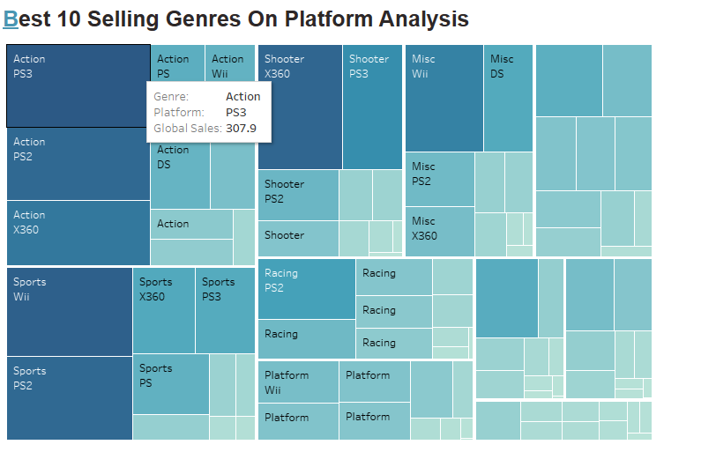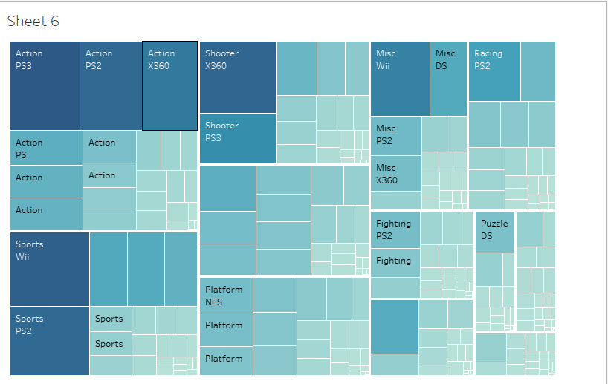

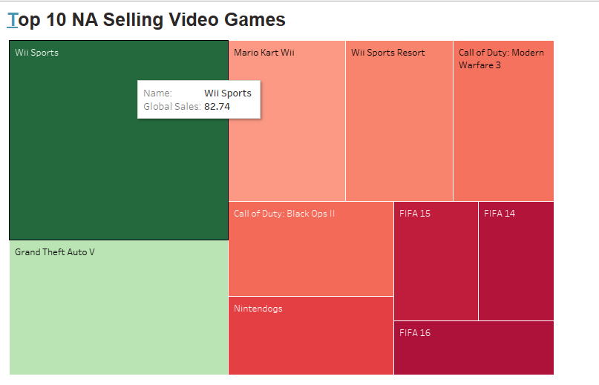

AFTER COMPLETING ALL THE VISUALIZATION WE ARE CEATING DASH BOARD BASED ON THE VISUALIZATIONS

Video games since its inception has touched many souls by their augmented reality and graphics apart from being a good to boredom it is also show us the way technology has been developed from single Ninendo to PS5, from road rash to God of war.

This project is a complete analysis of video games sold since 1980.It consist of video games with their publisher and platform with the genre of games on which year they were published with the sales they made in North America, Japan, Europe and other regions.

According to FMI, the video game market is expected to grow from US$ 227 billion in 2023 to US$ 805.3 billion by 2033. The demand for video games is anticipated to increase with the emergence of smartphones and advancements in hardware and software to improve the real-time rendering of visuals.

The video game industry is a titan in the global entertainment and media (E&M) sector, and it's experiencing an unprecedented surge in popularity and profitability. Total video game revenue is projected to rise from $262 billion in 2023 to $312 billion in 2027.16 Jan 2024

### Create Tableau Dashboard

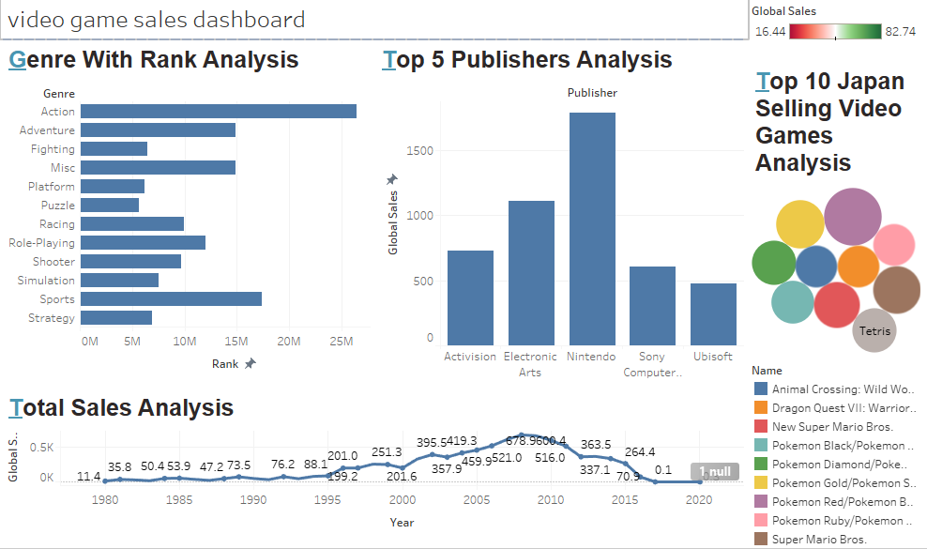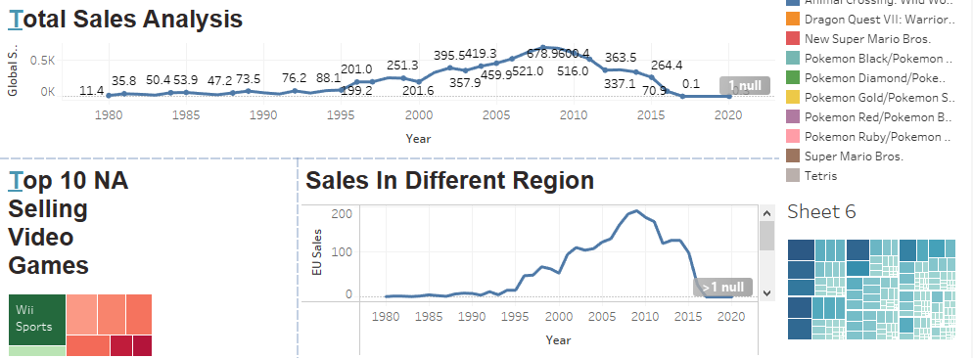

### Create Tableau Story

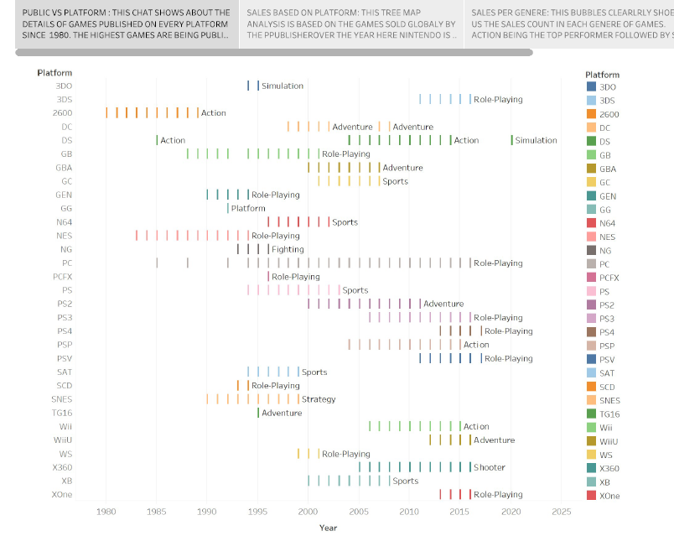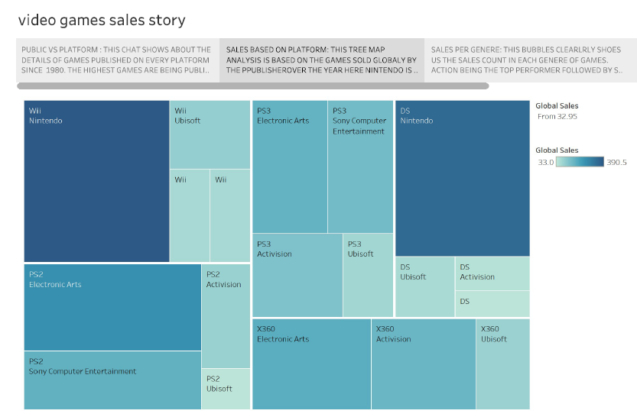PUBLIC VS PLATFORM : THIS CHAT SHOWS ABOUT THE DETAILS OF GAMES PUBLISHED ON EVERY PLATFORM SINCE 1980. THE HIGHEST GAMES ARE BEING PUBLISHED ON PLATFORMLIKE PS2,PS3,PS5,GB AND PC . IT IS CLEARLY SHOWS THAT GAME IN ACTIONGENER ARET THE HIGHET SOLD AND AND THE MOST MOST FAVORITE GAMES AMONG SALES BASED ON PLATFORM: THIS TREE MAP ANALYSIS IS BASED ON THE GAMES SOLD GLOBALY BY THE PPUBLISHEROVER THE YEAR HERE NINTENDO IS THE STAR WINNER BUT ALSO ELECTRONS ARTS.ACTIVISION AND SONY COMPUTER ENTERTINMENTS PLAYED A VITAL; ROLE IN THE GAME BEEN SOLD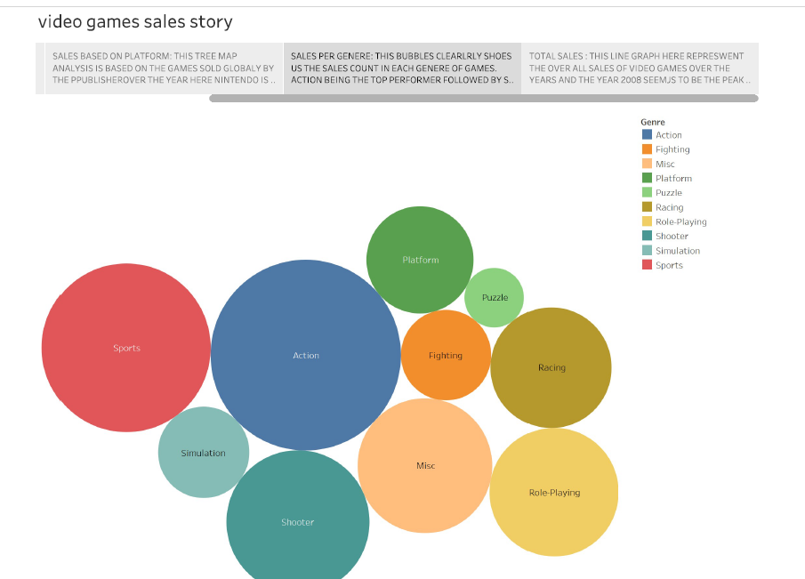

SALES PER GENERE: THIS BUBBLES CLEARLRLY SHOES US THE SALES COUNT IN EACH GENERE OF GAMES. ACTION BEING THE TOP PERFORMER FOLLOWED BY SPORT AND SHOOTING GAMES. GAMES ARE NOT VERY FRONT OF STRATEGICAL GAMES, THAT IS WHAT WE CAN INFER FROM THE BUSINESS

TOTAL SALES : THIS LINE GRAPH HERE REPRESWENT THE OVER ALL SALES OF VIDEO GAMES OVER THE YEARS AND THE YEAR 2008 SEEMJS TO BE THE PEAK YEAR WHARE THE SALES WAS HEIGHEST WE HAVE A AVERAGE LILNE HERE AND THE VALUE OF AVERAGE SALES CHANGING IS SHOWN BY THE GRAPH INIDICATING BLUE AS THE HEIGHEST SALES AND RED AS THE LOWEST SALES OF THE YEAR

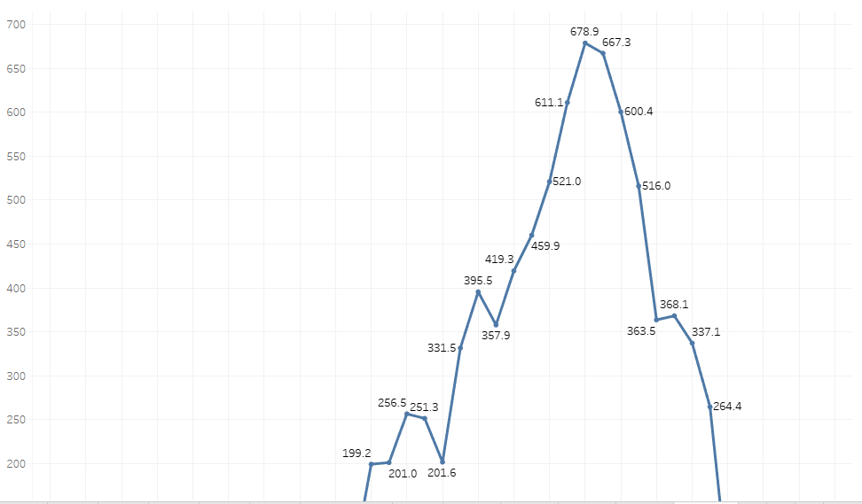

### Publishing And Web Integration

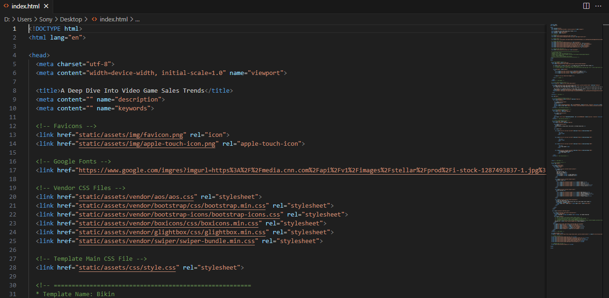

IN THIS WEB INTEGRATION WE HAVE UPLOAD THE EMBED CODE TO THE WEB INTEGRATION AND WE CAN RE CHANGE THE LINKS WE HAVE TO DOWNLOAD FROM BOTSTRAP FROM FOR CHROM WEBSITE FOR FREE AND WE CAN UPLOAD ALL THE LINKS FORM THE TABLUE PLUBIC AFTER RE CHANGE THE ALL LINKS WE CAN SEE THE BOOTSTRAP

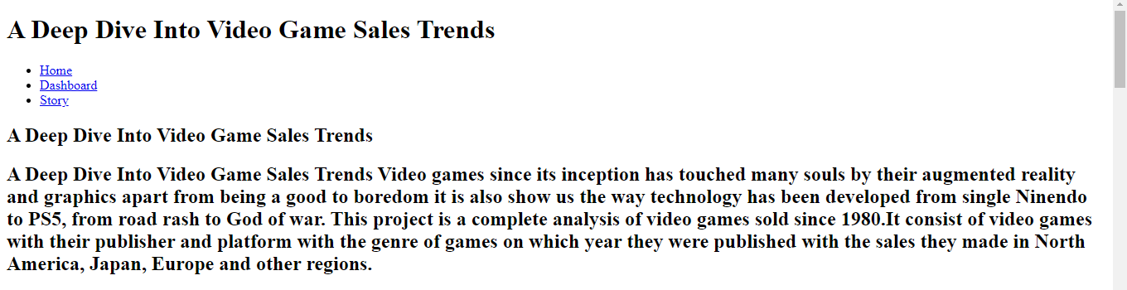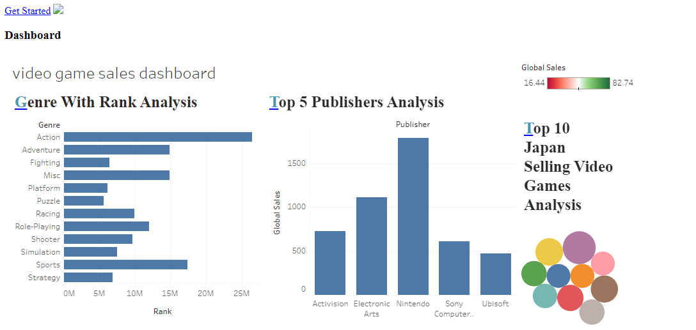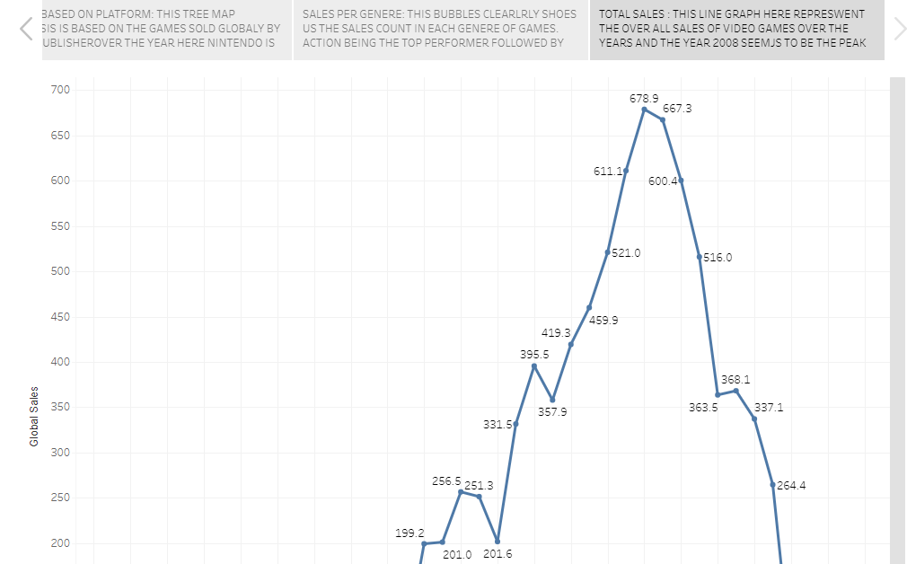 Create Tableau Public Account With Personal ID

#### 

### Using Bootstrap Templates For Web Integration

Conclusion:

* It is best opt for the games releasing in PC and also if you are looking for action games look for the publisher “Ninendo” as they have sold the highest number of games.
* The love for the video games was increasing exponentially till 2008 but it is gradually decreasing since then, this is due to the lack of creativity, awareness, or interest. This is the reason why most of the games are sold in North America as compared to the other part of the world.
* There are lots of efforts going into creating a single game and due to modern era mobile games other platforms are getting deprived of the attention which had created a lot of awesome experiences for gamers from 1980-2010.